HSE Fatigue and Risk Index
Managing the risk of fatigue among employees is an important safety consideration for individuals involved in shift work and/or irregular duty schedules. Tools are now available that combine scientific understanding of sleep and circadian rhythms in an easy-to-use electronic format that output estimates of the risk of fatigue associated with duties in a proposed programme of work. One such tool is the HSE Fatigue and Risk Index, which was developed by QinetiQ, in collaboration with Simon Folkard Associates.
The Fatigue and Risk Index requires users to input the duty start and end times along with some details about workload and breaks within a duty. The task can also be automated (reducing data entry) and linked to rostering software so that the risk of fatigue can be minimised at the planning phase.
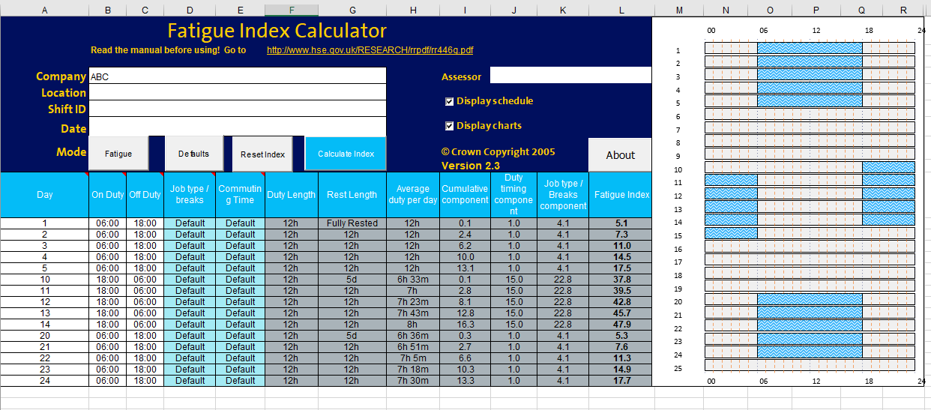
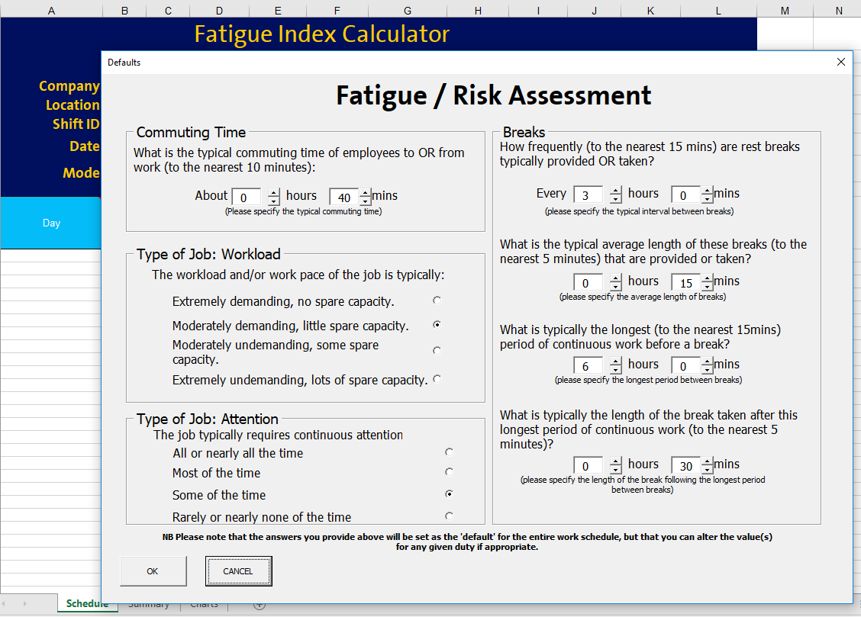

Please contact IPlicensing@qinetiq.com to discuss licensing of FRI software.

